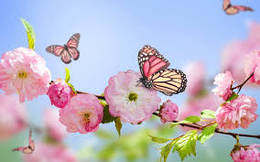 

**Castlecomer tidy town’s**

**Spring/summer newsletter**

**Volume 1, Issue 1 - April 2021**

* Welcome
* Spring 2021
* Projects
* Tidy towns competition 2021
* All Ireland pollinator plan
* Litter

A chairde,

Welcome to our very first issue of Castlecomer Tidy Town’s newsletter. We are excited to share our progress and projects with you. We encourage you to get involved in our activities in the coming months. We look forward now to the evenings being brighter and longer, with summer holidays around the corner we may make the best of our gardens this year while we stay at home and continue staying safe.



**Spring/summer 2021**

Planning started last September for this year. It has been a difficult few months due to covid restrictions but we have managed to continue our work in groups of 2, some volunteers worked alone. I can’t thank our volunteers enough for all their hard work over the last few months. Planting was carried out in autumn so we are now seeing the fruits of our labour. The town is really looking well and we have had great feedback from locals when we are out and about. We are also connecting with people through **Facebook** so please follow **Tidy Town Castlecomer** for regular updates. We have developed a new website courtesy of Graham Kenny; you will find us at www. Please log on and contact us if you would like to volunteer. From September 2021 we are looking forward to working with our local schools on their green flag initiatives, we will keep you informed through our social media of upcoming events. We look forward to brighter days ahead, until then hold firm



**Projects**

The project for this year was the rejuvenation of the square. We redesigned all large flower beds on the square this was a mammoth task as beds were dug up top soil replaced, then filled with organic manure thanks to Earl Delaney for all his help and donation of topsoil and manure. We then planted buxus hedging in 5 beds, to keep with the formal heritage of the town. New roses and hydrangeas were also planted as the old roses had become diseased. We have decided to keep the beds formal but also pollinator friendly by planting allium. Muscari, pony tail grasses, verbena, delphiniums. We will also plant some traditional summer bedding. A lot of work has also been undertaken at the discovery park, church of Ireland, and Cloghogue /wellie race road where we have decided to grow a wildflower meadow. Kilkenny Street will see the introduction of new street planters and balcony pots. Follow us on our webpage for upcoming projects.

**Tidy Town’s Competition 2021**

Castlecomer have entered the Tidy Town’s competition every year since 2001 and each year we have improved on the marks awarded. This year we hope to improve even further and who knows we might bring home some award!! Fingers crossed

The first Tidy Towns Committee was formed in the early 1960’s ably led by Canon William O’Keeffe P.P. Members included Kitty Dunne, Kit Holohan, George Murphy, Jo Kelly, Pat Owens, Tom Gleeson, Andy Brennan (Halad), Teresa Quinn, Martin O’Grady, Diarmuid O’Donovan and Packie Kelly. The volunteers were very active and were rewarded in 1967 when the town scooped the one and only recognition, the Bord Na Mona Award for best lawns. Over the years there have been numerous wonderful community people donning the mantle of responsibility notably Noreen Curry, Upper Ballyhemmon, David O’Rourke, Donaguile Heights and Dick Brennan, Donaguile. Today Dick Brennan remains a Stallworth loyal member and continues to serve as Treasurer.



**Litter**

Fed up of seeing litter scattered on our roadways and streets and destroying our amenity areas? You can help us by joining our organised litter picks weekly, details of same will be on our webpage and Facebook page.

You can also play your part by keeping outside your own shop or home litter free and tidy.

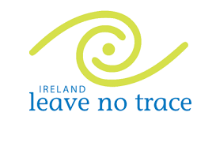<https://www.leavenotraceireland.org/education/education-introduction/>

**All Ireland pollinator plan**

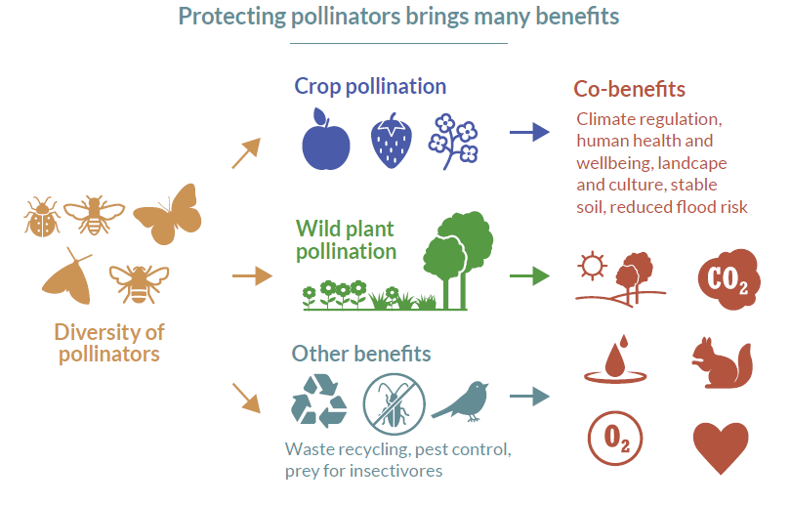 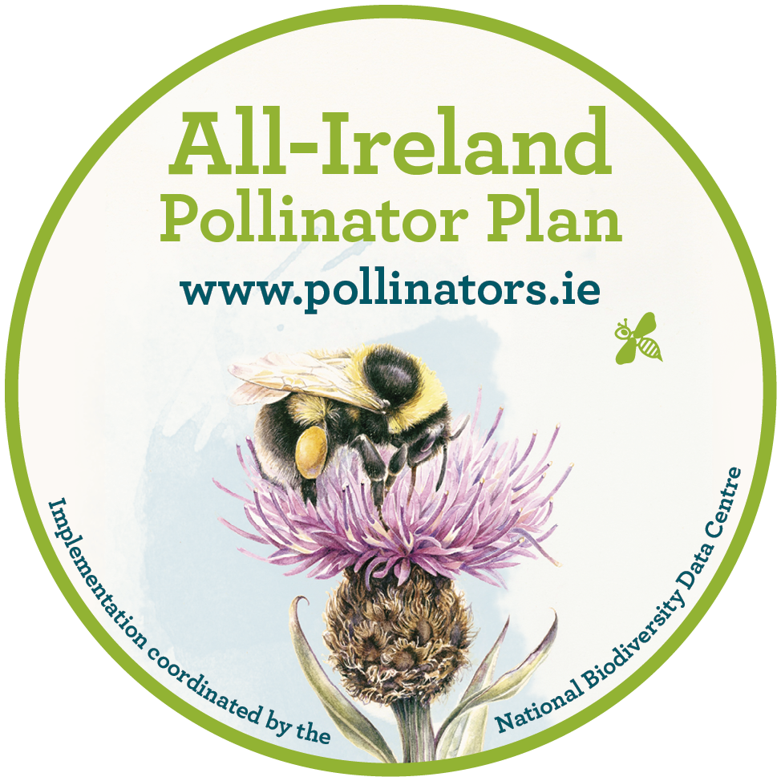

Irish pollinators are in decline. The problem is serious, and in

order to ensure the sustainability of our food production; to

avoid additional economic impact on the agricultural sector;

and to protect the health of the environment, it requires

Immediate attention.

The All-Ireland Pollinator Plan is a shared plan of action. By

working together, we can collectively take steps to help restore

pollinator populations to healthy levels. Over the next five

years, this plan will work to bring about a landscape where

pollinators can flourish.

Are you interested in pledging your garden for pollinators? Contact us!   
  
Find out more at [www.pllinators.ie](http://www.pllinators.ie)